**EXPERIMENT-5**

**Aim :** Design an Automatic Night Lamp.

**Apparatus:** Arduino, LDR, LED, Resistor (10K, 220), wires, Breadboard.

**Circuit diagram:**

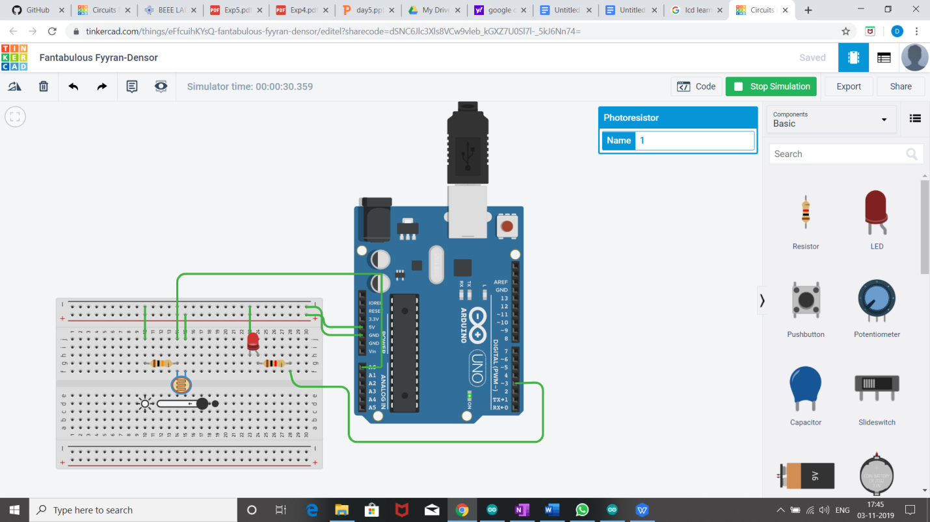

**Theory:**

**Concept used:**

* We have used the concept of **LDR(light dependent resistor)**..
* A photoresistor can be applied in light-sensitive detector circuits , and light -activated and dark -activated switching circuits.

**Learning and observations:**

* The resistance of a photoresistor decreases with increasing incident light intensity.
* In dark resistance become less and led glows.

**Problem and troubleshooting:**

* Check the range of sensor value for darkness correctly.
* Do not connect LED without resistance to avoid fuse.
* Connection should not be loose on breadboard.
* LED should be checked earlier to avoid any error.

**Precautions:**

* Check your port beforehand through which your arduino is connected with the system.
* Check the working of LDR beforehand.

**Learning Outcomes:**

* We have learnt the use of LDR which is light sensitive resistance.
* 0 to 5 volt is indicate by the sensor value from 0 to 1023.